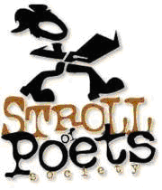
ANNOUNCEMENT FOR WORKSHOP PROPOSALS

CALL FOR WORKSHOP PROPOSALS AND SUGGESTIONS

The Edmonton Stroll of Poets is now accepting proposals and suggestions for our 2016/2017 season of workshops. Do you or someone you know have an area of expertise that might be of benefit to our dynamic and enthusiastic membership? No previous experience in facilitating a workshop is required. Please send a brief description of your proposal or ideas to John Leppard, Workshop Applications Facilitator (leppardjohn@hotmail.com). Deadline for submissions is September 6, 2016.

